Creating Endpoints
DMSMigrate or replicate Endpoints Create Endpoint
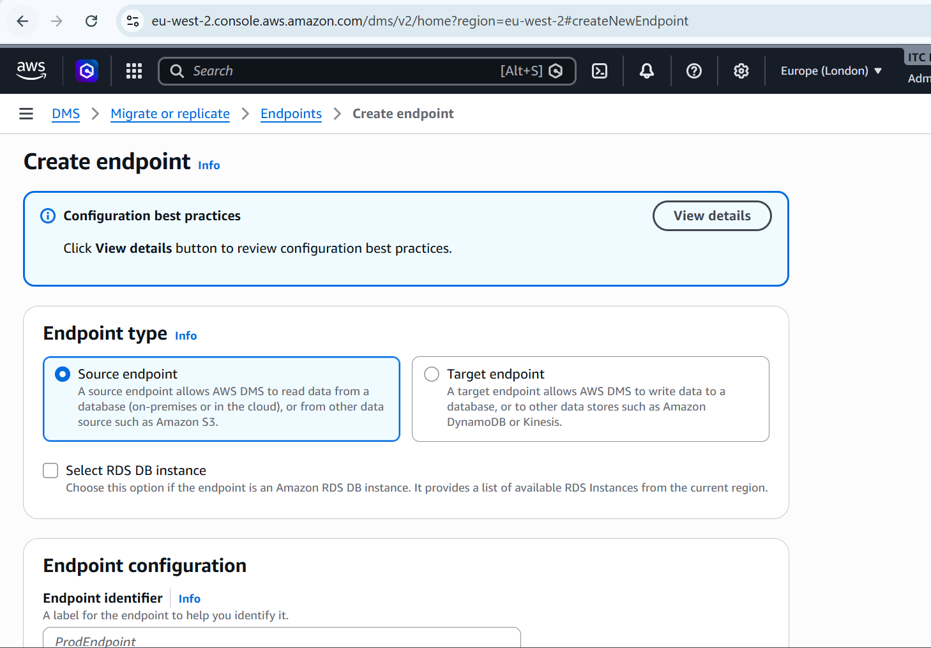
Click source endpoint
2. Enter the endpoint details
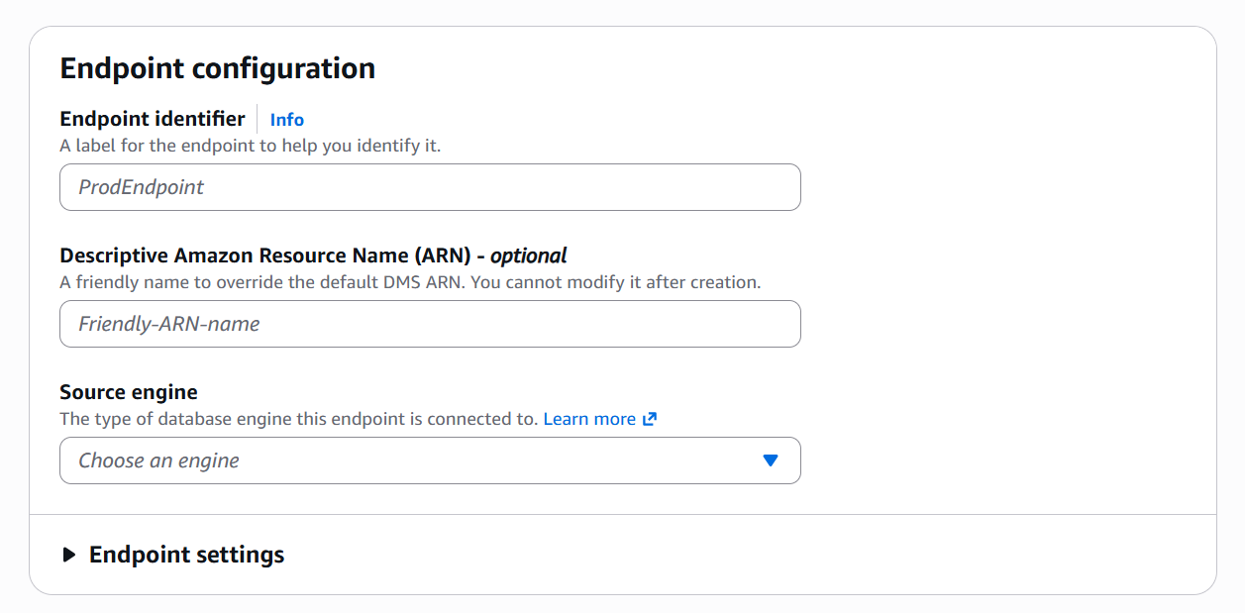
3. Enter the source Details
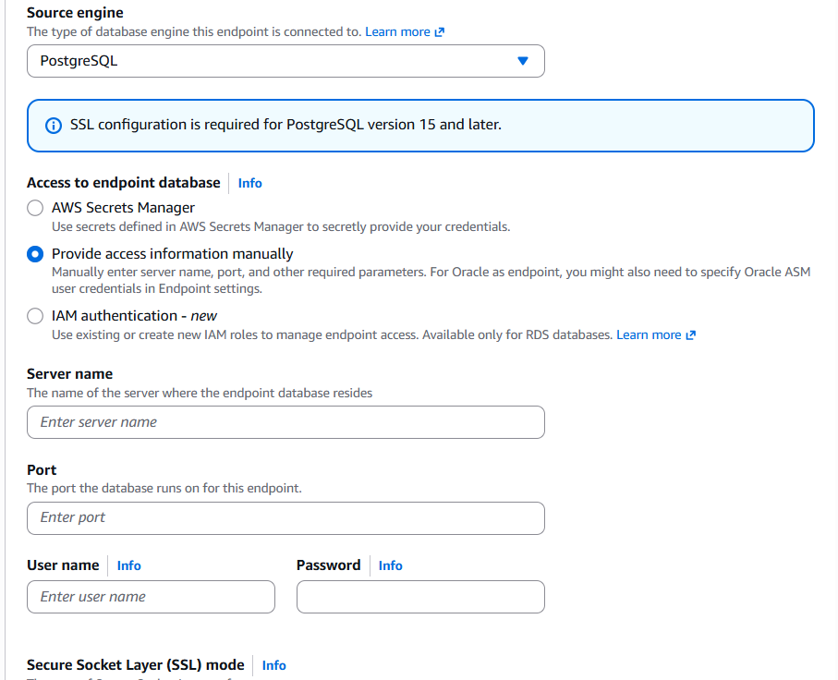
Source DB Name portusername Password DB Name
4. Add necessary tags
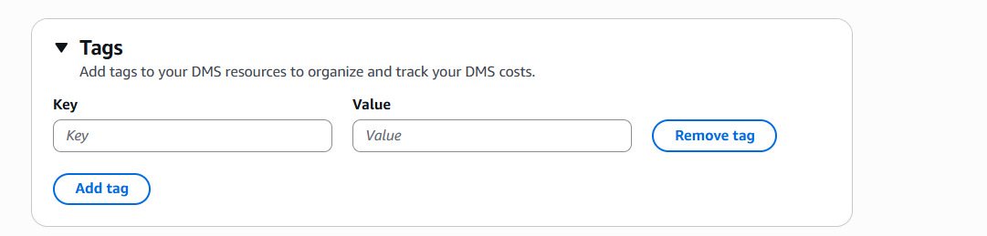
5. Test the connection
